**Run Node JS Application**

1. After installation of all pre-requisite software such as Node JS, Express JS, Joi and Nodemon, start the service by executing the command “npm start package.json”

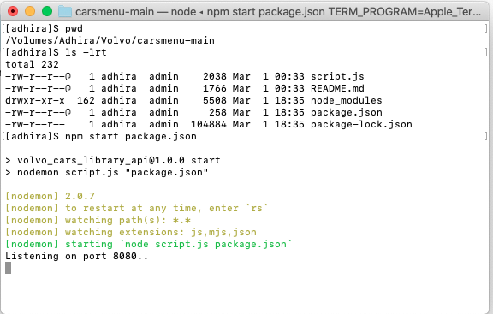

1. Open the browser and enter the URL <http://localhost:8080/api/cars>

